Lab 02 Group B4: David Gögl, Ved Varshney, Emre Eryilmaz
Postlab Q1:
In this section of the lab, we first intialize the serialPort using a baud rate of 115200. We then started working on hall_daq.c to intialize the char buffer. Using this char buffer, we were able to use the serialport functions to write and read into the serial port. Using the serial port we understood the values given by the sensor and were able to conver the value given by it to a voltage value by dividing the value by 4095 and multiplying it by 3.3 to get a voltage value between 0V and 3.3V.
Now that we had the sensor setup using serial communication we were now able to collect the quiescent voltage. We did this by removing the magnet from the system and averaging 20 readings from the sensor. Our measured average quiscent voltage was 1.513V

Postlab Q2:
In this section of the Lab we measured the noise provided by the sensor. We did this by plotting 50 data points provided by the sensor. For each point, it was either an averaged value of 1 reading, 20 readings, or 200 readings. We were then able to plot these values and get a standard deviation and and mean provided by each.

This gave us the data provided below for each readout with the standard deviation and the mean:

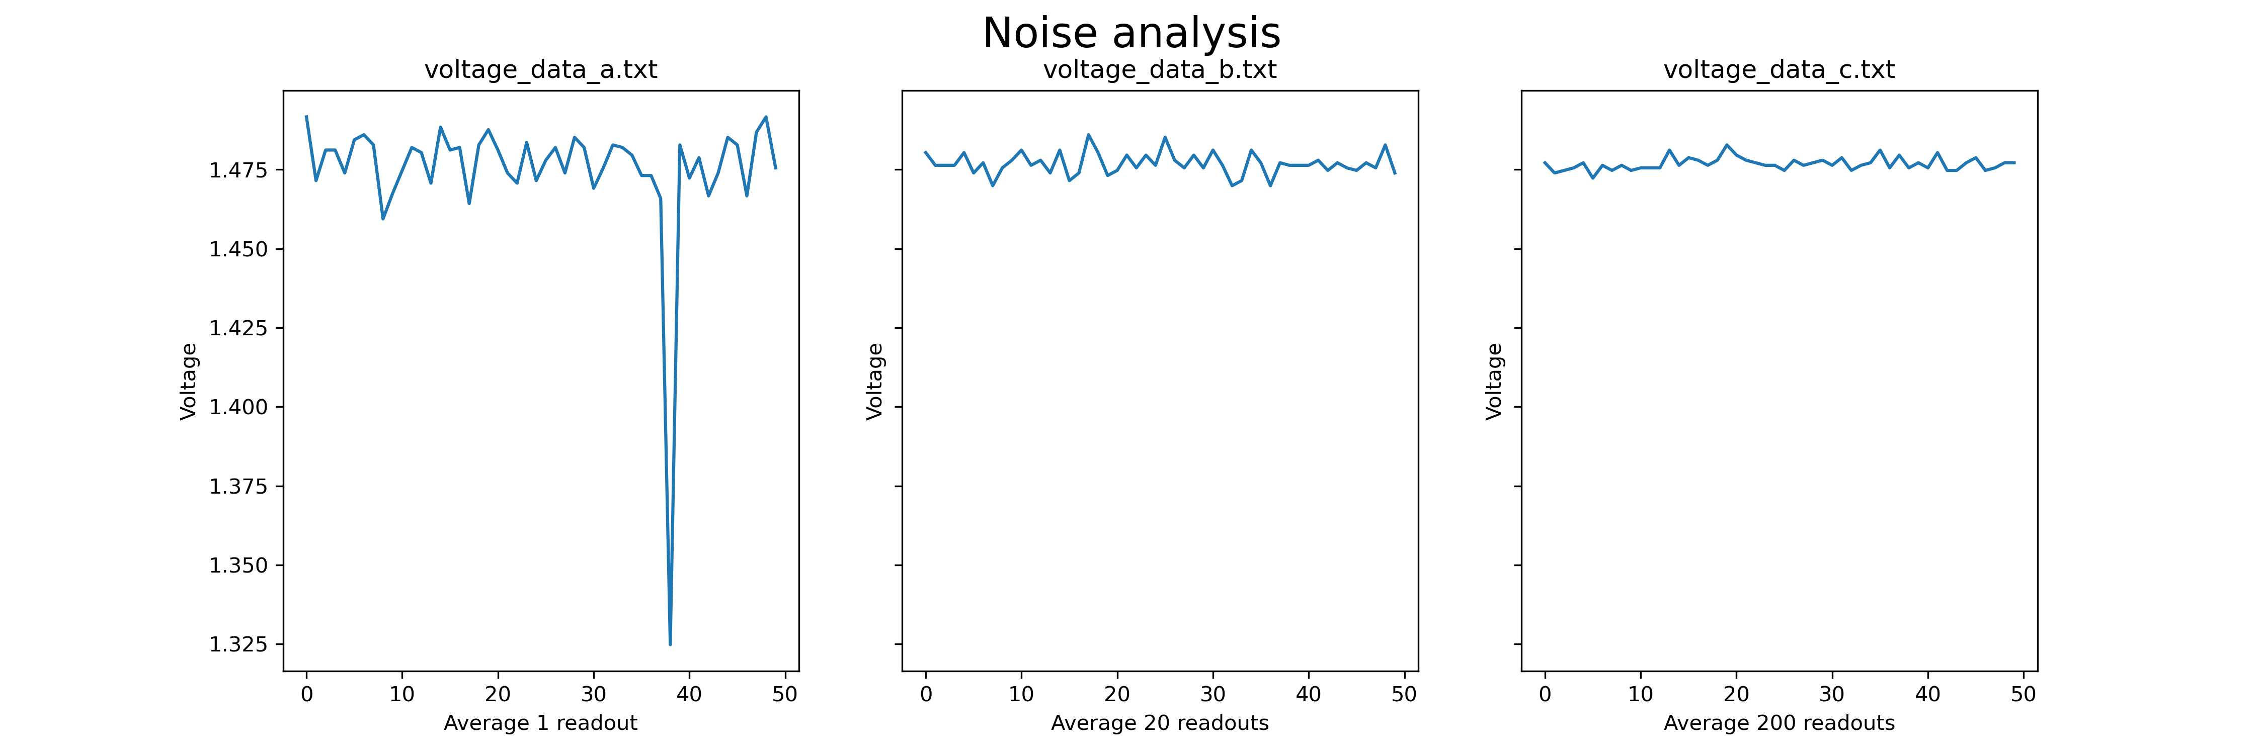

Postlab Q3:
This code measures the magnetic field at various distances from a magnet, and fits a function to the collected data to describe the relationship between distance and magnetic field strength. The physical phenomenon being measured is the magnetic field produced by a magnet at different distances from the magnet.
The code loads data from a generated text file, plots the data, and then uses Scipy's curve_fit function to fit a non-linear function to the data. The function being fitted is defined as "func", and it takes "z" and "B_r" as arguments. The "curve_fit" function is then used with "func" as the function to fit, "dist" as the xdata, and "field" as the ydata. The resulting fitted curve is then plotted along with the collected data. The final plot is saved as a png file.
